The beautiful Italian region of Trentino announces sunrise skiing, spa sunsets and a smorgasbord of culinary experiences for this winter season

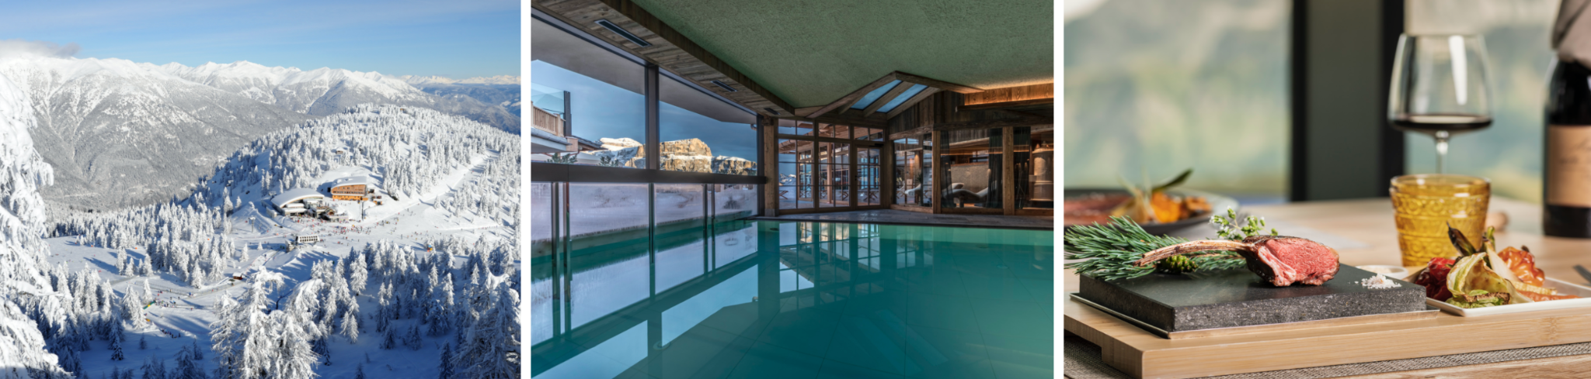

Travellers and locals alike can combine their love of skiing with bespoke gastronomical and wellness experiences within Trentino’s high-altitude, intimate mountain huts

In the Italian ski haven of Trentino, five-star quality denotes the hundreds of kilometres of pistes, lifts and world-class culinary experiences witnessed within the exclusive mountain huts scattered across the slopes. Surrounded by the enchanting landscapes of the Dolomites, skiers can be whisked away via snowmobile or snowcat, for a mountain hut dining extravaganza, championing authentic local flavours - the ultimate post-skiing refuel midday or evening.

The intimate mountain hut experience

In Val di Fassa, ski enthusiasts can spend the entire day on the upper valley’s most beautiful slopes, starting with an indulgent breakfast in the Buffaure ski area alongside show stopping views of the Catinaccio mountain range from the Baita Cuz hut. Skiers can promenade along the Panorama Skitour to Conca del Ciampàc, and dive down the black slope to Alba di Canazei where a modern panoramic cable car awaits, for seamless transportation to the heart of the Belvedere di Canazei ski area, boasting a 360-degree panorama of the peaks. The Ciampolìn mountain hut offers the perfect pit stop whilst the Fienile Monte mountain hut - accessible from the renowned Sellaronda - oozes understated glamour and houses an intimate restaurant at an altitude of 2,260 metres, with sunset views of the Dolomites’ famed enrosadira (alpenglow).
Heading south, Latemar Ski Center is a large ski area pairing skiing with five-star flavours in numerous huts. On the Trentino side, Chalet Caserina overlooks the Agnello slope - an open-air art gallery, peppered with works by internationally renowned artists who breathe life into RespirArt, one of the world’s highest art parks.

Alpe Cimbra’s Skitour dei Forti is dotted with a multitude of high-altitude mountain huts including Stella d'Italia and Baita Tonda, whilst Baita Neff is a classic log cabin in the heart of nearby Cimbra Forest. The Alpe Lusia ski area also offers a range of foodie sanctuaries, such as Chalet Valbona’s panoramic terrace, Lusia mountain hut, and Chalet 44 Alpine Lounge in the heart of the destination - a haven with local cuisine that honours mountain traditions and sleek decor, grand windows and a 600 square metre terrace providing spectacular views of the Pale di San Martino and the Lagorai mountain chain.

Trentino offers a host of other exceptional dining experiences that aren’t to be missed, including:

- In Alto Restaurant above Passo San Pellegrino, boasting a panoramic terrace overlooking the breathtaking Dolomites. After a refreshing pit-stop, the La VolatA slope will thrill the very best of skiers, known as the stage of World Cup competitions and assist in burning off the delicious local produce
- Malga Ces in San Martino di Castrozza, which has fused tradition with refined cuisine for over 70 years, using solely local produce
- Chalet Fiat, reflecting the glamour of Trentino’s Madonna di Campiglio, through a refined and decidedly alpine style
- Madonna di Campiglio’s Slow Food tasting event in March, championing local products and offering diners four dinners at high altitude to taste local ‘slow food’ products, every Saturday in March
- Orso Bruno and Solander Mountain huts in Folgarida-Marilleva - the best spots to taste Casolèt cheese and Solandra specialties
- Classic Trentino and seafood sunset dinners in La Roda Paganella hut - guests can enjoy exceptional bird’s eye views of the valley of the lakes as far as Lake Garda, then descend the legendary Olympic slope or Santel path to rendezvous at the warm and welcoming Sirio Dossòn and Alpine Lounge Meriz huts

Trentino Ski Sunrise:

Launching this month until March 2022, Trentino Ski Sunrise offers adventurers the exclusive experience of gliding the perfectly glistening slopes in the morning silence - punctuated only by the sound of blades cutting through hard snow - followed by a flavoursome breakfast celebrating local ingredients and traditional recipes authentic to the region, hosted in an intimate mountain hut.

Enthusiasts can also opt for the Sunset Ski experience in Madonna di Campiglio - torch in hand on the Brenta Dolomites - or skiing under the stars over the various floodlit slopes.

Trentino Sunset Ski: 10 & 24 February; 3 & 10 March.

Spa Sunsets:

Within an array of Trentino’s intimate mountain huts located on the slopes themselves, visitors can indulge in a private retreat with sunset views following a full-on day on skis.

2,225 metres above sea level - on the renowned Sellaronda slope in Col Rodella, Val di Fassa - the Salei mountain hut boasts a wellness oasis overlooking the Trentino Dolomites, equipped with saunas, heated pools and a private terrace for relaxation. Accessible via skis or Salei’s personal snowmobile from Passo Sella, rooms and suites are peppered with wood furnishings and homely lounge corners for a tranquil escape.

Further wellbeing offerings within Trentino’s collection include Solander hut’s regenerating spa in the heart of the Folgarida-Marilleva ski resort, overlooking the Brenta Dolomites; and Capanna Presena mountain hut furnished with a sauna and Jacuzzi at the foot of the Presena glacier in the upper Val di Sole.

- Further detail can be found below:
  - Salei Passo Sella
  - Capanna Presena mountain lodge
  - Nature Brenta SPA

-ENDS-

Media Enquiries:

Trentino Marketing is represented by LOTUS in the UK. Please contact Georgina Oakley and Lydia Matthews at trentino@wearelotus.co.uk or call +44 207 953 7470

For further info, please visit the Trentino media room: www.visittrentino.info/en/press.

