The 69th event to be held from 30 April to 9 May 2021
THE WORLD’S OLDEST MOUNTAIN CULTURE FESTIVAL

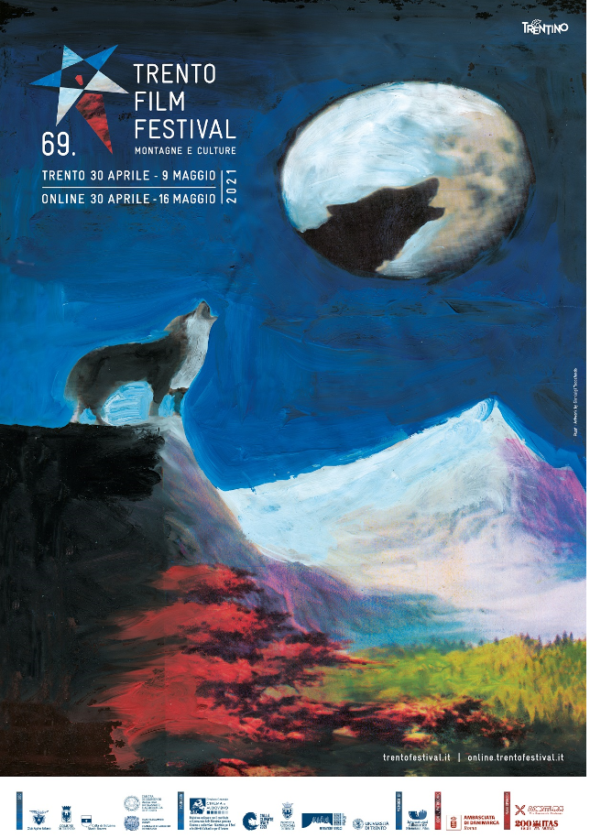

London, United Kingdom, 8th April 2021 - Since 1952, the Trento Film Festival: Mountains and Cultures has explored the changes in mountain and adventure experiences and culture. This year’s host country will be Greenland.

After the success of the “hybrid” event in August 2020, where works were streamed virtually for the first time, the historic festival of cinema and mountain cultures returns to its traditional spring location from 30 April to 9 May 2021. Eager to entertain the public with the best films and documentaries dedicated to the mountains and extreme terrains of the Planet, together with fascinating and often unpublished mountaineering events and literary presentations, participating films will be available to stream until 16 May 2021.
The 69th installment will feature a content-rich programme comprising several sections. From the International Competition, which will see feature and short films compete for the award of the prestigious Genziana D’Oro, to the surprises of the Special Screenings and the best of adventure film in Alp&ism, the ethnographic look at Terre Alte, Trentino-Alto Adige cinema in Orizzonti Vicini, and naturalistic cinema in Muse.Doc.

This year’s host country will be Greenland, the boundless Arctic land that has assumed ever greater international importance due to climate crisis and its environmental, economic and geopolitical repercussions. The special programme entitled Destination…Greenland of the 2021 Trento Film Festival invites you to discover this extraordinary and little-known place, also thanks to the patronage of the Embassy of Denmark in Italy. The film selection will be paired with several other events dedicated to Greenland, offered to the public both in person - in compliance with the regulations in force on the dates of the Festival - and via streaming.

MontagnaLibri, the world’s largest mountain publishing event will also return alongside the film programme. MontagnaLibri is a point of reference for the sector market and countless enthusiasts, and will feature many new editorial proposals.
The programme will soon be available on www.trentofestival.it

In particular, we recommend:

ICEMELTLAND PARK
by Liliana Colombo (Italy, United Kingdom)
An amusement park designed for families, couples, friends and everyone who wishes to visit. You don’t know where to go on holidays? Or, you are not sure how to spend your honeymoon? Come to Icemeltland Park, you won’t regret it!
Competition (short)

An online accreditation form will go live after Easter on www.trentofestival.it; the possibility of accreditation is geolocated for Italy, foreign journalists willing to take part can write to accrediti@trentofestival.it.

For information on visiting Trentino go to www.visittrentino.info/en

