HOME AWAY FROM HOME: TRENTINO’S FINEST MOUNTAIN HIDEAWAYS
FOR DIGITAL NOMADS

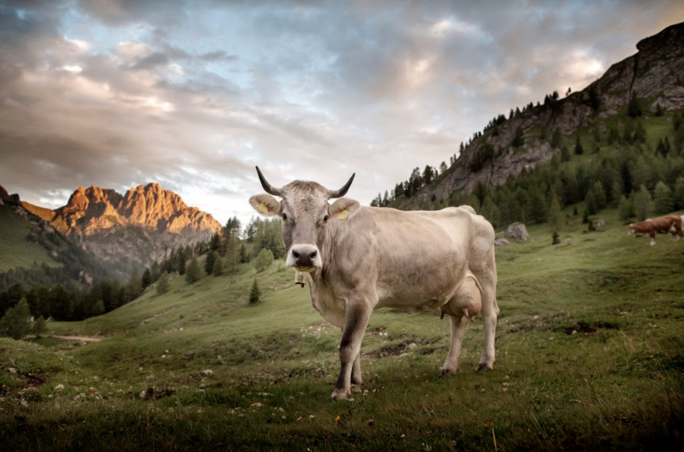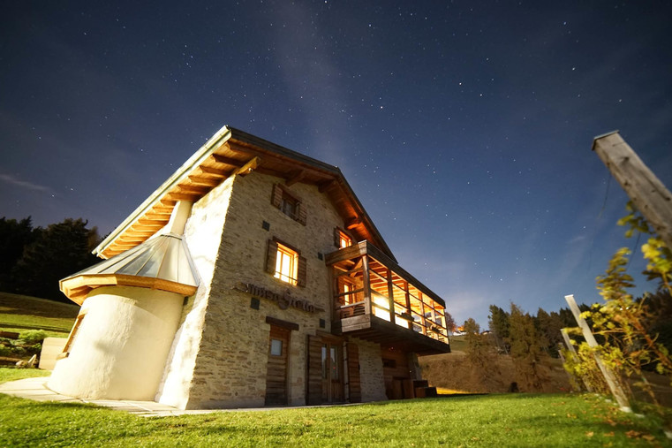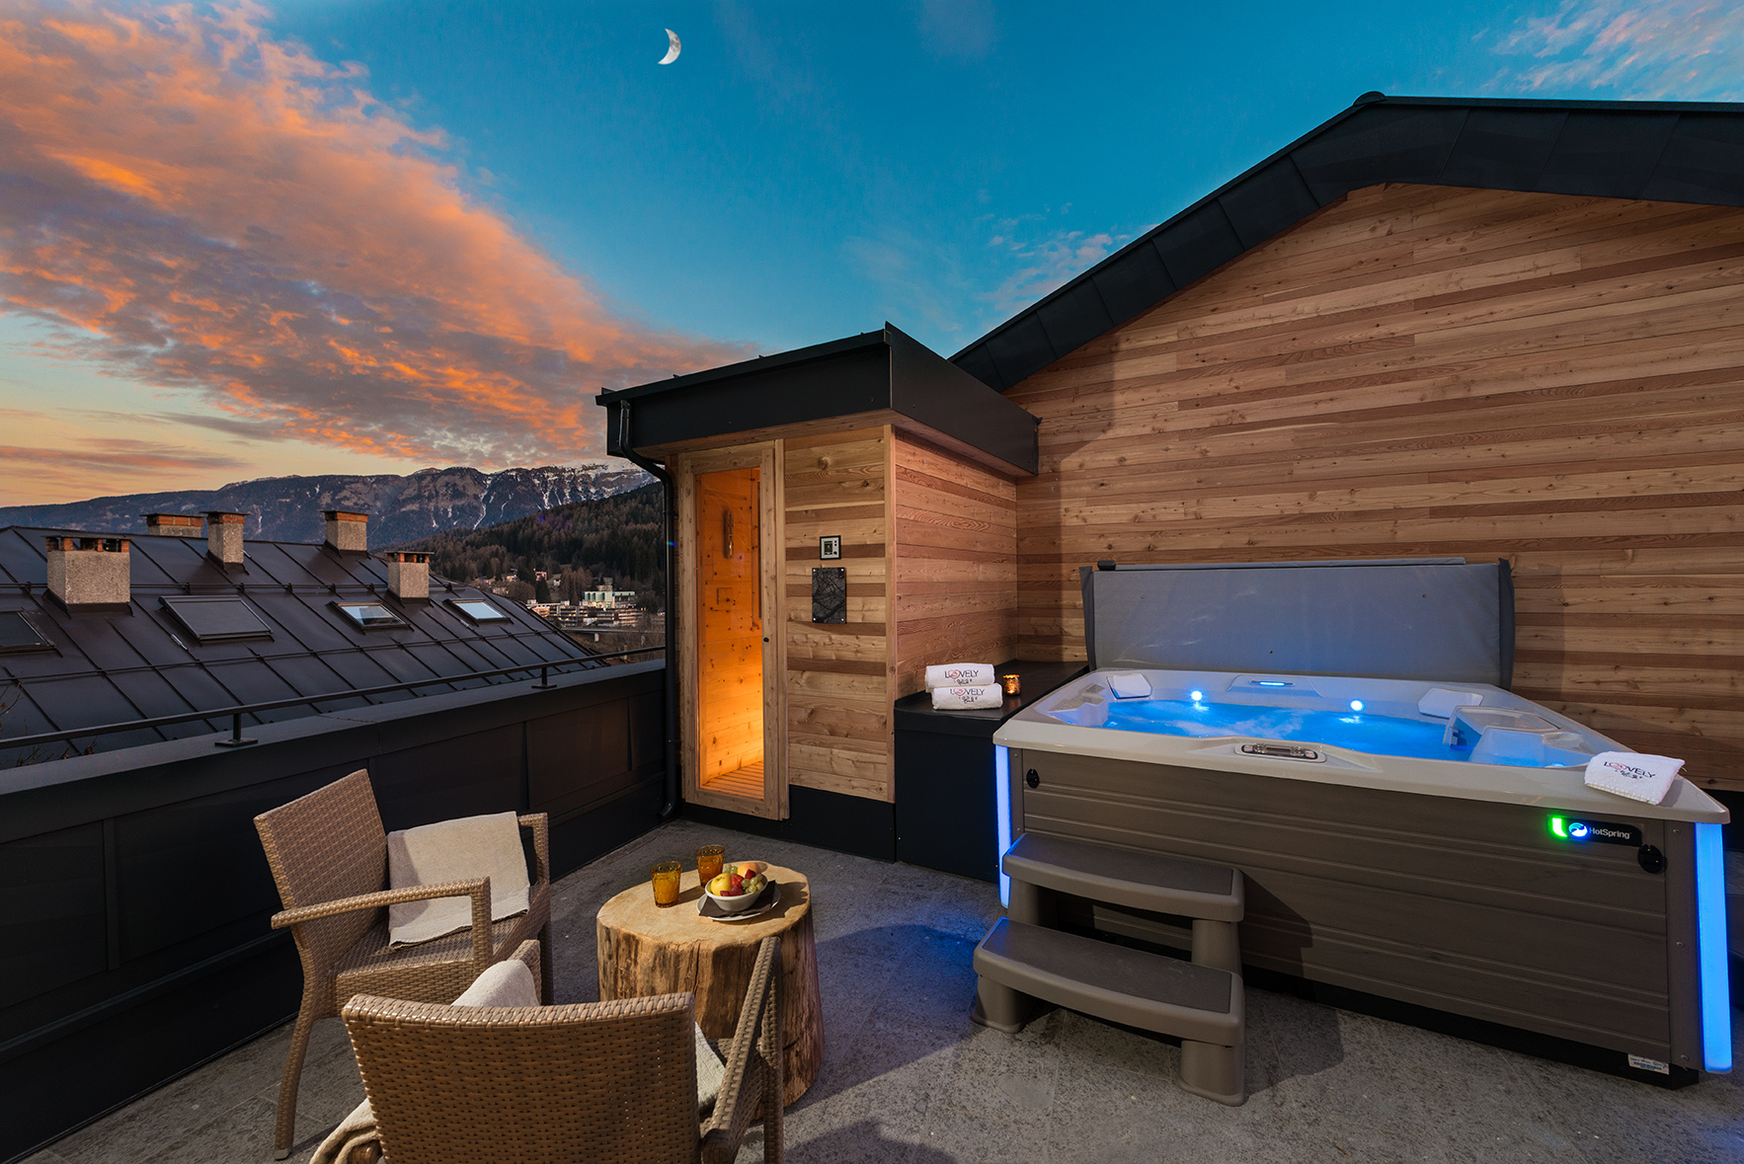

London, United Kingdom, 4th February 2021 - The increasing trend in remote work is providing the option for keen travellers to work from any desk in the world and Trentino in northern Italy is a prime destination for a ‘workation’. Since the region is home to almost 300 lakes, dramatic Dolomites walking routes, world-renowned wines, soothing spas and an abundance of work-ready private spaces, Trentino is the ultimate stop for digital nomads to balance work productivity with some of Italy’s famous ‘la dolce vita’.

Tristan Kennedy, travel journalist and editor of Snow Magazine and Active Traveller, has been working remotely in Trentino since last February. He says, “Never mind Bali or the beaches of Thailand, if you want to work remotely, Trentino is one of the best places in the world. The mountains are simply stunning, whatever the season, the welcome is always warm, and as for the food and wine... well, they're world class - this is Italy, after all! My partner and I get to go ski touring in the mornings before sitting down to a day's work. I still have to pinch myself that this kind of lifestyle is actually possible.”

Discover four of Trentino’s finest workation spaces:

Maso Stella, Valsugana
A true mountain hideaway for ultimate immersion in the mountain landscape
In a wild and remote part of Valsugana is Maso Stella, the beautiful mountain hut formed of two independent apartments - Ursa Major and Ursa Minor. Both apartments are made of natural wood and restored stone, with roaring open fires, well-equipped kitchens and panoramic views over the mountain valleys and lakes. Remote workers can switch off with miles of mountain walks, and routes that circumnavigate the crystal-clear waters of nearby Lake Levico and Lake Caldonazzo. After exploring Italy’s great outdoors, guests can cosy up in Maso Stella’s private spa with an Alpine wood sauna, hydrotherapy shower, heated wood lounger and candle-lit relaxation space. There are plenty of comfortable, daylight-flooded desk spaces to use, and guests at either of Maso Stella’s apartments will have full wi-fi access, and a printer and copier upon request. There are a handful of mountain hut restaurants and pizzerias nearby, some of which even deliver authentic mountain cuisine to Maso Stella’s doorstep. www.masostella.it

Agritur Artemisia, Val di Fiemme
Traditional meets modern to enhance workplace wellbeing
Formed of three apartments which sleep up to twelve, four or two people, Agritur Artemisia fuses traditional mountain architecture with stylish modern furnishings. Apartments feature open-plan living spaces, floor-to-ceiling windows and patio doors, creating calming spaces that foster a sense of wellbeing for remote workers. Set in the charming, artistic village of Tesero, guests can wander past boutiques and local grocers, or walk amongst meadows, streams, cattle and pine forests as they explore the many rural villages of Val di Fiemme. Val di Fiemme is also on the Dolomites Cycle Path, a 50km route which guides cyclists through some of the most breathtaking countryside scenery the Dolomites has to offer. A large, bright workspace overlooks the Rio Stava stream, and guests will have full wi-fi access and a printer and copier upon request. www.www.agriturartemisia.it

Lovely Lodge Ravelli, Val di Sole
Luxury home comforts in a world-famous mountain biking spot
Nestled within the peaks of Val di Sole, Lovely Lodge Ravelli is a collection of six luxury lodges serviced by Palace Hotel Ravelli. Offering true mountain decadence, the lodges each have private rooftop facilities including open-air hot tubs and saunas that lodge guests will have exclusive use of. Remote workers can enjoy all of their home comforts and more: coffee machines, plasma screen TVs and his and hers basins complete with luxury toiletries are found in each lodge. Along with the various tables and workspaces, Palace Hotel Ravelli can arrange desks for guests, and the hotel’s printer and copier are available to use. Val di Sole is the host of the 2026 Mountain Bike World Championship, so it’s no surprise that the area has some of the finest mountain biking routes Europe has to offer - the perfect way to let off steam after work. For a more peaceful way to unwind, the area is home to Stelvio National Park, the largest nature park in the entire Alpine region. Here, visitors can walk amongst wildflowers, roam rugged pastures and discover many incredible lakes. www.ravellihotels.it/luxury-lovely-lodge/

Nonno Ghino, Altopiano di Piné
A traditional mountain hut close to one of Italy’s best cities for living
Nonno Ghino is a typical Italian mountain hut located in Altopiano di Piné, a landscape sculpted by gentle hills, vineyards, lakes and meadows. Interiors are beautifully traditional and made almost entirely of local wood, whilst outside, remote workers can enjoy a spacious garden, a terrace with a dining table, a wood-burning barbecue and a cosy hammock. Double beds, bunk beds and fold out beds mean that Nona Ghino sleeps up to eight people, and with a private wellness centre complete with a Turkish bath and Finnish sauna the property is perfect for spending long stretches of time. Guests will find plenty of lakes, forest bridleways and the Laghestel Biotope nature reserve nearby, but the capital city of Trento is also just 25km away. With its dramatic Renaissance buildings, Roman piazzas and famous MUSE science museum, Trento has repeatedly been named as one of Italy’s best cities for quality of life. Guests at Nonna Ghino will have full wi-fi access and a printer and copier upon request.
www.visittrentino.info/it/bedollo-di-pine/appartamenti-privati/baita-nonno-ghino_dr20625265

For information on visiting Trentino go to www.visittrentino.info/en

