Gianmaria Stelzer
Luthier / Trento
Gianmaria, purebread Trentino, born in 1986, started to attend the “I Minipolifonici” music school when he was just four years old. He remained at the same school right up until completion of his studies as a cellist, in 2006. After finishing high school (classical high school), he enrolled in the Faculty of Environmental Engineering in Trento, but the cello continued to be an integral part of his everyday life, so in 2007 he enrolled in the Civic Luthiery School of the Municipality of Milan. At the same time, in Trento he attended a specialised course for the construction of string instruments, under the guidance of Maestro Luca Primon.
In 2010, at the International Luthiery Competition in Pisogne, he obtained a special out-of-category award for his first viola d’amore. At the same event, the following year, he won the gold medal in the “Young luthiers - cellos” category, with an instrument built in a group effort with French luthier Jérémie Bonnet.
Today, as a professional luthier, he builds and also repairs and restores string instruments, dividing his time between his workshops in Trento and in London, where he assists luthier Philip Ihle part time. In each of his instruments, he loves to inscribe a more or less renowned quote. His personal double bass bears a quote attributed to Gustav Mahler, which states: “Tradition is not the worship of ashes, but the preservation of fire”.

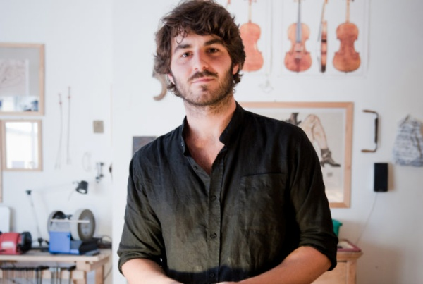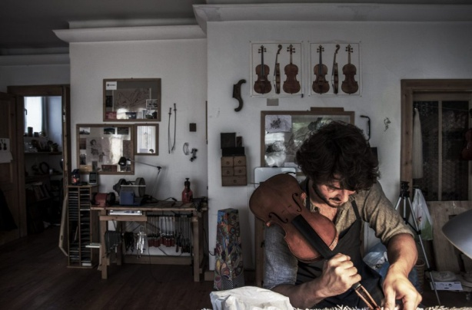

LINKS
http://www.inviolinoveritas.com/gianmaria-stelzer/

