TRENTINO INVITES VISITORS TO EXPLORE ITS LAKES AS THE PROVINCE WELCOMES NEW PANORAMIC GLASS FUNICULAR WITH LAKE GARDA VIEWS

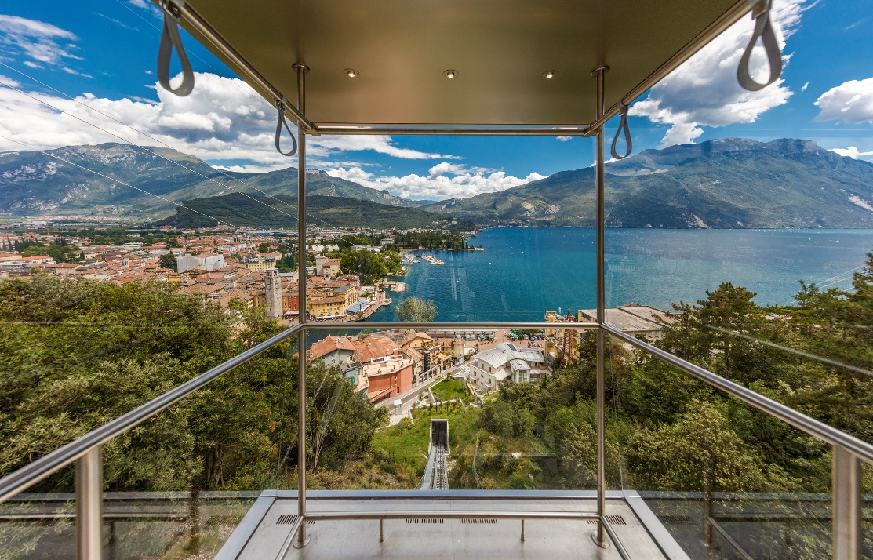

3rd August 2020 – The region of Trentino in northern Italy, which stretches from the northern tip of Lake Garda up into the Dolomites, is excited to welcome the brand new panoramic glass funicular*, Riva-Bastione. The new funicular connects the historic centre of Riva del Garda with the Bastione di Riva hilltop fortress in just two minutes. The fortress, which lies at an altitude of 130m on the slopes of Mount Rocchetta, dates back to the early 16th century following Venetian rule in Riva and until now could only be reached on foot via a 30-minute hike. The funicular cabin, made entirely of glass, rewards visitors with sweeping panoramic views of the iconic lake and resort of Riva del Garda as they traverse the hillside. Once they arrive at the top, visitors can then relax with a drink and aperitivo or enjoy a traditional meal in the newly renovated bar and restaurant.

The province of Trentino is home to over 300 lakes, many of which are located at altitudes of over 1,500m and are of glacial origin, which offer the perfect setting for both relaxation and exciting water sports as they transform into an outdoor aquatic gym.
Windsurfing and Watersports
For windsurfing enthusiasts, the winds of Garda Trentino blow daily, with the Pelèr wind sweeping over the northern tip of the lake in the morning and Ora blowing in the afternoon attracting windsurfers of all abilities from all over the world. For those who want to harness the wind aboard a sailboat, Garda is a prestigious destination beloved by sailors across the globe.

Located a little higher up from Riva del Garda is Lake Ledro, boasting several different water sports, from sailing to windsurfing and SUP to canoeing. Out of the water, visitors can enjoy one of the most popular and beautiful walks and pet-friendly Pur Beach, located on the southern shore of the lake.

Those who love water sports and are seeking a family-friendly holiday will love the twin lakes of Levico and Caldonazzo in Valsugana just 20km from Trento. Both lakes were awarded with the Bandiera Blu [Blue Flag] as recognition of their clean waters and high quality of facilities and services. Caldonazzo Lake is the largest lake located entirely within the region of Trentino and in summer guests can enjoy water skiing here as it is the only lake in the entire region where this sport is allowed. Its banks offer the perfect stop for a swim or to kick back and relax with a picnic on its beaches.

Lesser known Lakes of Trentino
Named the "most beautiful lake in Italy" by Legambiente and the Italian Touring Club, Trentino’s Lake Molveno reflects the peaks of the Brenta Dolomites in its pure waters. The village of Molveno located on the north shore of the lake boasts the Bandiera Arancione [Orange Flag] of the Touring Club. With its 12 hectares of beach, English-style lawns and numerous play areas, it is a true natural lido of the mountains.

Picturesque Picnics
Lake Tenno offers picturesque picnics with views of the turquoise diamond-shape lake surrounded by woodland. The lake is close to the mediaeval village of Canale di Tenno, one of the most beautiful villages in Italy. The village has remarkably preserved its original layout since 1211, visitors will be overwhelmed by the intricate cobblestone paths, arches and stone houses. Stop off for the perfect lunch or dinner and try a signature dish in Trentino, ‘carne salada’.

With the UK government featuring Italy on its list of exempt countries and no quarantine arrangements required either side, now is a great time to explore all that the lakes of Trentino have to offer with their stunning scenery, crystal clear waters and range of accommodation offerings.

For more information on exploring the lakes of Trentino go to www.visittrentino.info/en/experience/lake-holidays
or for information on visiting Trentino go to www.visittrentino.info/en

-Ends-

Note to editors:
*The new Riva-Bastione funicular timetable runs between 08.30 to 0.00 from July 10th 2020 to October 31st, 2020, and 10.00 to 23.00 from November 1st 2020 to January 31st 2021 and throughout March 2021. A ticket costs €3 one way or €5 round trip during the day and only €2 round trip between 18.30 and 0.00. The Garda Guest Card also includes one free trip (one way).

Images:
A selection of images of the Riva-Bastione funicular can be downloaded here: https://we.tl/t-56yA82Qosj

TRENTINO GUEST CARD
The Trentino Guest Card is issued by all accommodation facilities in the region at no additional cost. It allows free access, or considerable discounts, to more than 100 sites across Trentino including museums, castles, nature parks, thermal baths, Acroparks, wineries and much more. It also allows free travel on public transport within the provincial territory. The card can also be downloaded via the Guest Card App created for Android and iOS. And thanks to the app, it is now even easier and more convenient to use public transport by downloading a digital ticket directly to your device which simply needs to be validated once on board or at the station. An upgraded guest card is also available to visitors to add additional services for a specific territory such as ski lift access in the summer, weekly entertainment and guided excursions in the parks. www.visittrentino.info/it/system/trentino-guest-card-old-en

