Unmissable winter events in Trentino, Northern Italy
The region welcomes a theatre made of ice and sunrise skiing experiences
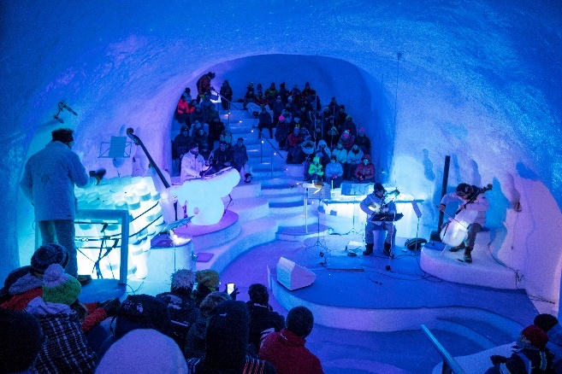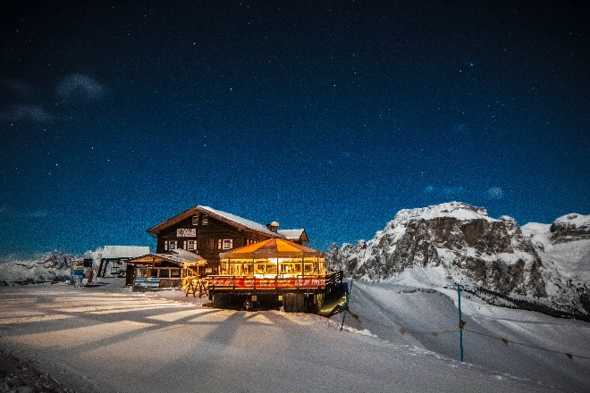

The Trentino region of Northern Italy may be home to world-class skiing, snowboarding and snowshoeing experiences, but there are also unmissable winter events taking place throughout the first few months of 2020. The unique ‘Ice Music’ festival at the ski resort of Passo Tonale will showcase a calendar of live music performances taking place in its 200-seat ice theatre, using instruments made almost entirely of ice. Meanwhile, the Ski Sunrise programme sees Trentino’s various ski areas open at dawn on select mornings, enabling skiers and snowboarders to make the most of the pistes’ most quiet, peaceful hours.
‘ICE MUSIC’ FESTIVAL
Trentino’s Val di Sole area welcomes the Ice Music festival each year, returning to the ski resort of Passo Tonale from 4th January – 28th March 2020. Ice Music is a programme of live music performances that take place in a 200-seat amphitheatre made of ice at an altitude of 2,600m, an idea that American artist Tim Linhart had and turned into a reality. Each performance in the Ice Music festival uses only instruments made of ice to create unique sounds and striking visuals. Every Thursday the Ice Music orchestra, ParadICE, perform at 3pm and 4.30pm whilst a variety of ice-infused pop, jazz, rock and classical performances take place on Saturdays at 4pm and 6pm.
With atmospheric coloured lights illuminating the ice dome and the unique sounds of instruments made almost entirely of ice, the Ice Music festival is an extraordinary mountain experience that makes for the perfect après-ski activity.
More information on the Ice Music festival can be found here: www.visittrentino.info/en/guide/events/ice-music_e_4631893
SKI SUNRISE MORNINGS
Trentino’s Ski Sunrise event returns to the Dolomites each year to give skiers and snowboarders the chance to carve through fresh powder at dawn, with a programme of sunrise pistes open across dates in December – March. The Ski Sunrise programme sees skiers meet at times between 5am and 6am to use lifts that have been opened early especially for their use, enabling skiers and snowboarders to weave their way through quiet, untouched pistes as the sun rises. After a brisk morning of skiing at dawn, visitors are invited to experience a special buffet breakfast with local produce from the region in the traditional mountain huts which have opened their doors early to welcome those attending Ski Sunrise events.
There are 30 Ski Sunrise events taking place between 26th December 2019 – 26th March 2020, with the Dolomites ski areas of Madonna di Campiglio, Val di Sole, Val di Fiemme, Val di Fassa, San Martino di Castrozza, Alpe Cimbra, Paganella and Monte Bondone all taking part.
The full programme of Ski Sunrise events can be found here: www.visittrentino.info/en/guide/events/trentino-skisunrise_e_318133

To learn more about Trentino, please see www.VisitTrentino.info

-Ends-

Note to editors:
Images of Trentino can be downloaded here: gallery.visittrentino.info/en/

For further press information, please contact:
Daniela Resenterra, dresenterra@hillsbalfour.com / 020 7593 1771
Chloe Gorman, cgorman@hillsbalfour.com / 020 7593 1756

