A WORLD OF WELLNESS IN TRENTINO
After a day on the snow, visitors will benefit from the variety of new wellness facilities and thermal experiences in Trentino

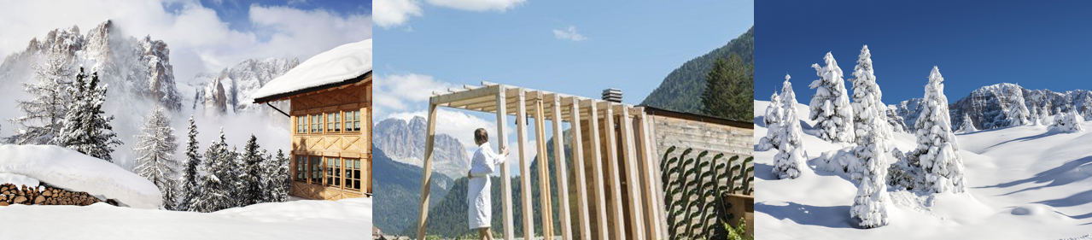

XX November 2019 - The region of Trentino in Northern Italy is a paradise for skiers, snowboarders and winter lovers - combining snowy alpine landscapes with unique local spa rituals and an abundance of wellness centres makes Trentino a well-placed wellness-boosting destination. Developments to Trentino’s wellness offering for the 2019/20 winter season include the rise of the ‘Aufguss’ sauna ritual, a Ferrari Wine sauna experience, and a brand-new 5* luxury wellness resort near the ski resort of Madonna di Campiglio.

‘Aufguss’ in Trentino
In the Italian mountains saunas are part of the traditional way of life, but a new take on the sauna experience in Italy is the ‘Aufguss’ - a sauna ritual during which an expert ‘Aufgussmeister’ circulates warm air, scents and steam around the sauna using a towel in a rhythmic motion. Instead of ordinary water, Trentino’s saunas often add snow to the hot stones to bring minerals from outdoors in to the experience indoors. Visitors can head to Malga Millegrobbe in Lavarone, an ancient Cimbrian cheese hut specialising in gourmet food and mountain wellbeing, where the Aufguss is a popular choice for visitors and locals alike.

Family wellness in Andalo
Besides the stunning Dolomite peaks that surround it, the ski resort of Andalo also boasts the newly renovated ACQUAin wellness centre, a family-friendly wellness offering with spray parks, slides, five swimming lanes, a hydrotherapy bath and calming Nordic thermal circuit with a Sauna Master on hand to guide visitors to ultimate relaxation.

A wine-cellar inspired sauna
For visitors who want to enhance their wellness whilst soaking up some of the local wine culture, QC Terme Dolomiti in Pozza di Fassa offers a wine-infused sauna experience in collaboration with Ferrari Wine Cellars. The ‘Sauna con Perlage’ is designed to mimic the sights and scents of a Ferrari wine cellar with more than 150 wine bottles adorning the outside of the sauna, 50 original wooden cases making up the internal walls and more than 500 Ferrari Trento corks forming the sauna seats. Combining two pillars of Italian and Trentino-style hospitality, the Ferrari sauna is completely unique to QC Terme Dolomiti.

New luxury eco spa resort in Pinzolo
The beautiful woodland area of Pinzolo, near Madonna di Campiglio, welcomed a brand-new luxury spa hotel on 1st August ahead of the 2019/2020 ski season. The 5*Lefay Resort & SPA Dolomiti is a brand new luxury eco resort which houses one of the largest spas in the Dolomites, spanning over 5,000sqm across four floors. Spa users will find nine different saunas, a World of Water and Fire and indoor and outdoor pools that are perfect for winding down after a day in the snow. Spa therapies have been designed to blend classic Chinese medicine principles with modern Western techniques, meaning post-ski treatments are healing and restorative.

Following in the footsteps of the first Lefay resort in Lake Garda, Lefay Resort & SPA Dolomiti is a carbon neutral hotel committed to conserving energy and resources to the highest degree. The Grual Organic Restaurant serves delicious Italian meals that are made with local, sustainably-sourced produce whilst the bedrooms were designed to recreate the atmosphere of the Dolomites mountain range indoors. Bedrooms are wide with plenty of open space, daylight and natural materials. Prices start at 320 euros per night with breakfast included. dolomiti.lefayresorts.com/en

To learn more about Trentino, please see www.VisitTrentino.info

-Ends-

Note to editors:
Images of Trentino can be downloaded here: gallery.visittrentino.info/en/

For further press information, please contact:
Daniela Resenterra, dresenterra@hillsbalfour.com / 020 7593 1771
Chloe Gorman, cgorman@hillsbalfour.com / 020 7593 1756

