FIVE WAYS TO SPEND AN AUTUMN BREAK IN
TRENTINO, NORTHERN ITALY
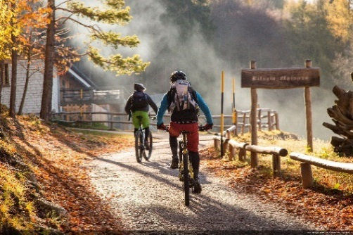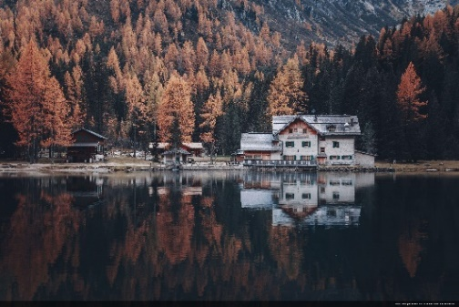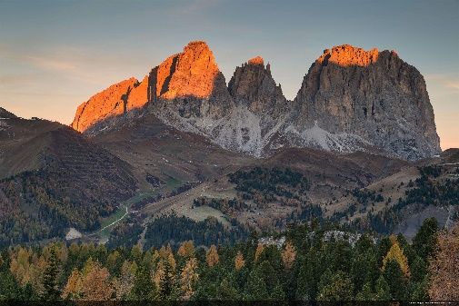

XX September 2019 - The region of Trentino in Northern Italy stretches from the northern shores of Lake Garda up into the Dolomite mountains, where visitors can travel from the Mediterranean to the alpine in less than one hour. In the autumn months the landscape bursts into colour and a variety of activities are on offer for visitors looking to make the most of the changing scenery. Whether it’s by walking or cycling through golden forests, feeling at one with nature by camping comfortably, or exploring one of the region’s historical cities, there are so many ways to celebrate the arrival of autumn in Trentino.
Here are five top ways to welcome the new season in the region of Trentino…
- Woodland walks through golden forests

The changing colours of Trentino’s woodlands make for exciting and varied walks in autumn. The Paganella Plateau region connects five scenic villages, with easy and exciting walking routes through dense beech woods that surround a sprawling lake. Alternatively, in the Stelvio National Park in Val di Rabbi, the Saènt waterfall ring route takes walkers to the feet of spectacular waterfalls created by the Rabbies river. Along this route the larch trees look like torches when lit by the sun, creating an intensely bright shade of gold.

- Explore historic castles in Rovereto

Strategically located over a rocky hill on the bank of the river Leno, the beautiful Rovereto Castle has the imposing structure of a military fortress and is an important example of Venetian Alpine fortification. Since 1921, the castle has housed the Italian Historical War Museum, Italy’s richest collection of WWI and WWII artefacts, including a railway cart pierced with shrapnel and a renowned collection of war weaponry. Rovereto is an ideal town for lovers of history to explore, with several museums and the Campana dei Caduti, meaning bell of the fallen, which is rung 100 times in the centre of town each evening in memory of those who were lost in the wars.

- Autumn’s ‘aperitif hour’

‘Aperitif hour’ is part of Trentino’s culture: an hour in the early evening to be spent sipping on an aperitif as the sun sets over the region. One of the finest spots to enjoy an aperitif is in Sardagna, which can be accessed via a cable car from Trento. Bistrot Trento Alta in Sardagna provides a breathtaking vantage point with sprawling views across the city, particularly in the golden haze of autumn. Visitors should be sure to choose a Trentodoc, Trentino’s world-class sparkling wine and an important symbol of the region.

- Camping in comfort

Trentino’s many comfortable camping options mean that visitors can be at one with nature even in the autumn months, with warm chalets, washing facilities and even campsites with on-site spas. Head to Camping Brione in Riva del Garda, a 4* camping ground where visitors can catch the last of the summer rays with camping areas, private bathrooms, internet access, mobile homes, a swimming pool, mini golf course and a 100 year old olive grove. Meanwhile, Camping Vidor Family & Wellness Resort in in San Giovanni di Fassa boasts 4* spa facilities including thermal areas, relaxation lounges, a sauna and menu of wellness treatments.

- Scenic cycling routes

Cyclists of all abilities are catered for in Trentino, where cinematic routes are available to cycle on either a mountain bike or an e-bike. The cross-country Tenno Tour largely covers paved paths, providing unparalleled views of Lake Tenno and the picturesque villages in the Tenno area where quaint stone houses are huddled together.

To learn more about Trentino, please see www.VisitTrentino.info

Images of Trentino can be downloaded here: gallery.visittrentino.info/en/

-Ends-

For further press information, please contact:
Daniela Resenterra, dresenterra@hillsbalfour.com / 020 7593 1771
Chloe Gorman, cgorman@hillsbalfour.com / 020 7593 1756

