NEWS FROM THE SLOPES:
Trentino’s Dolomites Ski Resorts Gear Up For The Ski Season

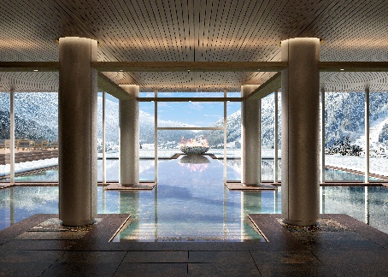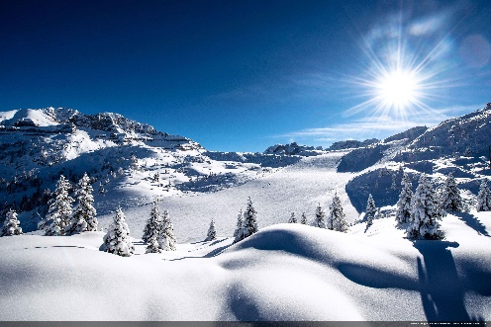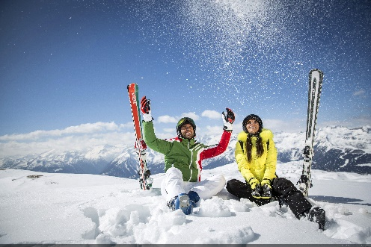

XX October 2019 - Trentino, the region of northern Italy that stretches from Lake Garda up into the Dolomites mountains, becomes a winter wonderland during the ski season with several ski resorts offering hundreds of kilometres of piste for beginners through to experts. New additions to the region include a new state-of-the-art luxury spa resort in Madonna di Campiglio with world-class eco-credentials, and Trentino’s Free Ski Day which allows skiers across the region to claim a free ski pass for the day and a two-hour ski or snowboard lesson. Additionally, the Paganella Ski Area has been expanded by 10%, making it one to watch for skiiers headed to the Dolomites.

New luxury eco-resort in Madonna di Campiglio
The beautiful woodland ski area of Madonna di Campiglio welcomed a brand new luxury spa hotel on 1st August ahead of the 2019/2020 ski season. Lefay Resort & SPA Dolomiti is the brand new stylish, luxury eco resort that houses one of the Dolomites' biggest spas, spanning over 5,000sqm across four floors. Spa users will find nine different saunas, a World of Water and Fire and indoor and outdoor pools that are perfect for winding down after a day in the snow. Spa therapies have been designed to blend classic Chinese medicine principles with modern Western techniques, meaning post-skiing treatments are healing and restorative.

Following in the footsteps of the first Lefay resort in Lake Garda, Lefay Resort & SPA Dolomiti is a carbon neutral hotel committed to conserving energy and power to the highest degree. The Grual Organic Restaurant serves delicious Italian meals that are made with local, sustainably sourced produce whilst the bedrooms were created to recreate the atmosphere of the Dolomites inside. Bedrooms are wide with plenty of open space, daylight and natural materials. Bedrooms start at 320 euros per night with breakfast included. www.dolomiti.lefayresorts.com/en

December 14th - Free Ski Day takes place across Trentino
Free Ski Day takes place on 14th December 2019 across Trentino, during which free 2 hour ski lessons are offered for children, adults, beginners and experts alike. Lessons vary from the basics of skiing to cross country skiing to snowboarding, and on Free Ski Day skiiers and snowboarders can take advantage of free ski/board hire and a free ski pass for the day. The initiative is designed to help more people learn to ski and to encourage exploration of the Trentino ski areas. All visitors need to do is book a lesson with one of the participating ski schools. www.trentinosci.it/it/scuole
Additionally, visitors can choose a weekend package that includes accommodation, a 2-day ski pass at the price of one day (2 for the price of 1), 2 hours of lessons on Saturday morning, and equipment hire for the duration of the lesson.

Expansions to popular ski areas
The main new attraction skiers will find this winter will be in the Paganella ski area which is set to expand by 10% this season. In this area a new gondola lift system will be opened, with cabins that can carry up to 10 people, ferrying 2400 to 3000 people per hour. It will leave from Pian del Dosson (the midway station for the cable car system that goes from the centre of Andalo to Doss Pelà), and will reach 2000m at La Selletta. At the same time, a new piste will be created - the 2 km red Selletta-Dosson piste - which will run alongside the system's route and, as with all the other pistes in this ski area, will be equipped with a modern programmed snow-making system.
To link the new piste to the existing network, a 400 m long junction piste will also be formed, connecting Rifugio Malga Zambana to the new Dosson-Selletta route. As a result of the works in the Paganella ski area, the available skiing area will be increased by 10%.

The San Martino – Passo Rolle Ski area has seen an investment of almost 5 million euros ahead of the ski season, with one of the most notable additions being the new six-seater Cogolera chairlift. With an hourly capacity of 2000 people and a total travelling time of just 3 and a half minutes, the new chairlift services the Cima Tognola area that has seen refurbished and extended pistes and new snow cannons fitted, making it an emerging Dolomites ski spot.

To learn more about Trentino, please see www.VisitTrentino.info

Images of Trentino can be downloaded here: gallery.visittrentino.info/en/

-Ends-

For further press information, please contact:
Daniela Resenterra, dresenterra@hillsbalfour.com / 020 7593 1771
Chloe Gorman, cgorman@hillsbalfour.com / 020 7593 1756

